**DAILY ONLINE ACTIVITIES SUMMARY**

|  |  |  |  |  |  |  |  |
| --- | --- | --- | --- | --- | --- | --- | --- |
| **Date:** | **19/05/20** | | | | **Name:** | **Huda Sultana** | |
| **Sem & Sec** | **VIII A** | | | | **USN:** | **4AL16CS0039** | |
| Online Test Summary | | | | | | | |
| **Subject** | | **Big data analysis** | | | | | |
| **Max. Marks** | | **30** | | **Score** | | **20** | |
| Certification Course Summary | | | | | | | |
| **Course** | **Introduction to Ethical Hacking** | | | | | | |
| **Certificate Provider** | | | **Great Learner Acdemy** | **Duration** | | | **6 Hours** |
| Coding Challenges | | | | | | | |
| **Problem Statement:** | | | | | | | |
| **Status: Solved** | | | | | | | |
| **Uploaded the report in Github** | | | | **Yes** | | | |
| **If yes Repository name** | | | | **Hudasulltana/online_certificate**  **Hudasulltana/online_coding** | | | |
| **Uploaded the report in slack** | | | | **Yes** | | | |

BDA online internal screeshots:

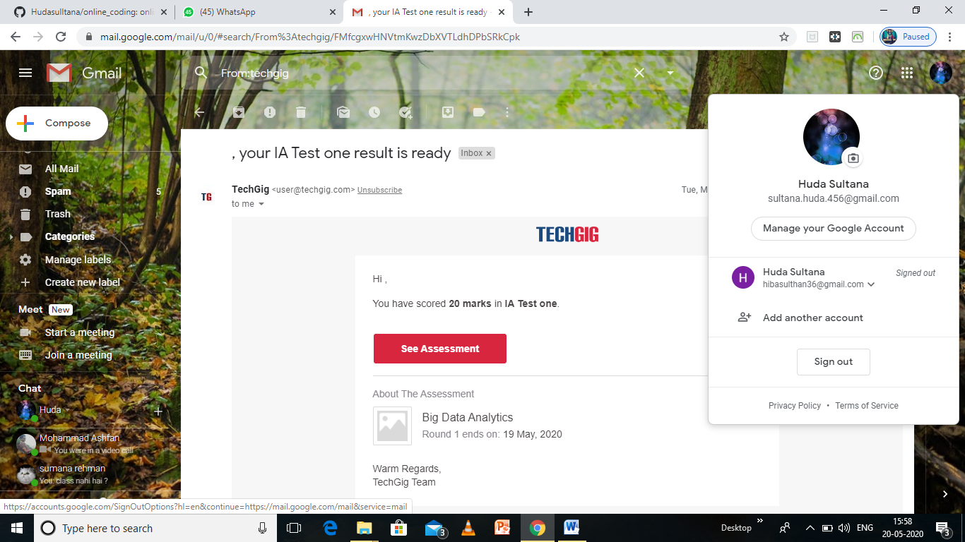

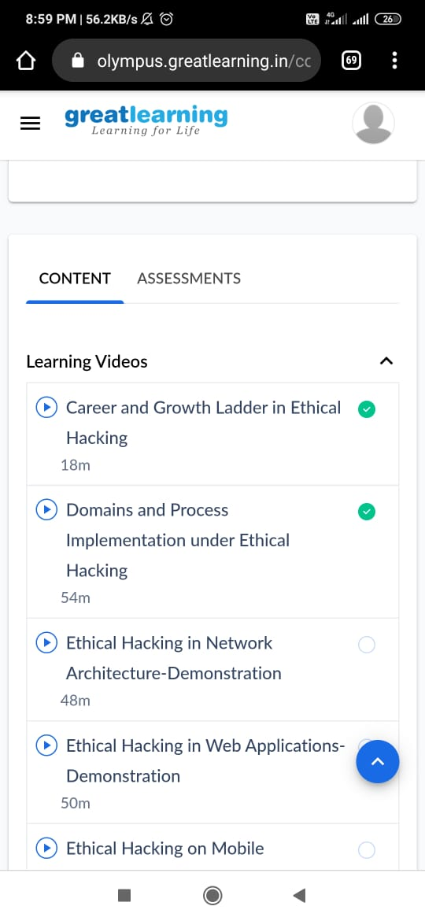

Online certification

Program

package shortestpalindromeexample.java;

import java.util.Scanner;

public class ShortestPalindromeDemo {

public static String shortestPalindrome(String str) {

int x=0;

int y=str.length()-1;

while(y>=0){

if(str.charAt(x)==str.charAt(y)){

x++;

}

y--;

}

if(x==str.length())

return str;

String suffix = str.substring(x);

String prefix = new StringBuilder(suffix).reverse().toString();

String mid = shortestPalindrome(str.substring(0, x));

return prefix+mid+suffix;

}

public static void main(String[] args) {

Scanner in = new Scanner(System.in);

System.out.println("Enter a String to find out shortest palindrome");

String str=in.nextLine();

System.out.println("Shortest palindrome of "+str+" is "+shortestPalindrome(str));

}